|  |
| --- |
| CURRICULUM VITAE |

**NAME ASHOK KUMAR SHARMA**

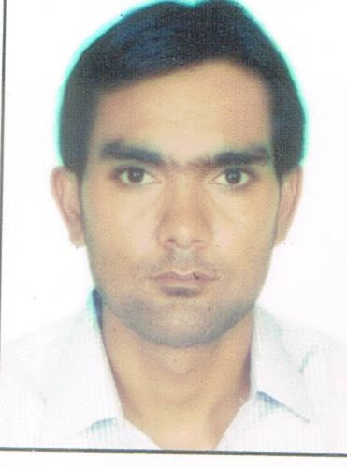

**Email ashoksharma.bpr@gmail.com**

**Contact No.** **+95-9789161435( Myanmar)**

Permanent Address

*Jyoti Nagar, Behind of Krishna Nagar,*

*Bharatpur, Rajasthan-321001*

TITLE

**Manager(Project & Billing)** with **8.5 years** Working Experience in **Telecom,Solar,Real Estate& Industrial Projects.**

CAREER OBJECTIVE

**Seeking a challenging position in a reputed organization which provides opportunities for professional growth and advancement, and utilize the experience acquired in becoming a valuable team member in the company.**

## PROFESSIONAL QUALIFICATION

**Diploma in Civil Engineering from Board of Technical Education, Rajasthan in 2007.**

## COMPUTER PROFICIENCY

**Basic Knowledge of Computers such as MS-Word, Excel, Power Point, Internetetc.**

## Job Profile

* **Overseeing and coordinating the day to day running of projects by assisting project head and senior managers. Also involved in the development, updating and monitoring of business and action plans.**
* **Project plan and control with project execution.**
* **Site execution planning**
* **Team Movement to site**
* **Dealing with customer to solve the issues related to sites.**
* **Making weekly customer review meeting presentation**
* **Preparation of invoice and follow-up with customer for payment.**
* **Maintaining project Trackers & Different Reports on daily basis.**
* **Analyzing of site progress and different activity.**
* **Coordination with SCM team to deliver proper material in right time to site.**
* **Reviewing contactor/vendors manpower deployment..**
* **Monitoring manpower deployment.**
* **Providing project support to senior Project Managers. Reviewing the efficiency and effectiveness of service delivery.**
* **Responsible for handling the projects finances.**
* **Communicating with project head to report on project status.**
* **Resolving any financial queries that are raised.**
* **Involved in Coordinating projects from inception to completion.**

## WORK EXPERIENCE

**Total Work Experience – 8.5 Years**

|  |  |  |  |  |
| --- | --- | --- | --- | --- |
| **NAME OF ORGANIZATION** | **CLIENT** | **PROJECT** | **LOCATION** | **PERIOD** |
| **MKG Group** | **IGT,Telenor** | **Telecom** | **Myanmar** | **Jan-2015 to Till Date** |
| **Umaxe Projects Pvt. Ltd.** | **Supertech Ltd.** | **Real Estate & Industrial Projects** | **Greater Noida** | **Jan-2013 to Dec.-2014**  **(2 year)** |
| **Zamil Infra Pvt. Ltd** | **Aircel,Bharti Infratel,Spaice,Mero Mobile,EMTEL Etc.** | **Telecom& Solar Project** | **INDIA,NEPAL,MAURITIUS,KSA** | **April-09 to Dec.-12(3 year,8month)** |
| **Nokia Seimens Network(P) Ltd** | **Vodafone & Indus** | **Telecom Project** | **Jaipur (India)** | **June-07 to March-09(1year,09month)** |

## PERSONAL DETAILS

**Father’s Name : Sri Gordhan Sharma**

**Date of Birth : 30-June-1986**

**Sex : Male**

**Marital status :** **Married**

**Languages Known : Hindi and English**

**Nationality : Indian**

**Hobbies : Reading, Playing**

## DECLARATION

**I hereby declare that the above given information are true and to the best of my knowledge.**